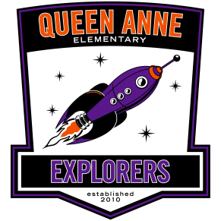

Dear Friend,

My child attends Queen Anne Elementary. On behalf of my child and all the children of Queen Anne Elementary, thank you for considering a donation to our “Reach for the Stars” Auction, taking place March 8, 2013. 100% of Auction Proceeds help fund educational services for our children.

Queen Anne Elementary is a public school with excellent teachers, a dedicated principal, and excited and engaged students, whose parents are dedicated to our school and our community. We thank you for contributing to our fundraiser. Your kind donation will impact the lives of all Queen Anne Elementary children!

As a donor, you will not only be supporting a worthy cause, your business will also be featured at the event, in communications to the parents and kids, and on our school website, which is an important source of daily information for our Queen Anne families.

PTSA –raised funds pay for the following:
Curriculum Enrichment like art and music classes
Tutoring Program
Additional help for teachers to reduce the teacher/child ratio in class
Field Trips
Community/Family Events

The PTSA is a 501(c)3 organization and your donation is tax-deductible to the extent of the law. To make a donation please just give us a call and we will be happy to pick up the gift certificate or anything else you would like to include.

We would like to obtain all donations by February 1, 2013.

Thank you in advance for your support and for making a difference in the lives of our children!

Sincerely,

On behalf of Queen Anne Elementary

Queen Anne Elementary PTSA is a Non-Profit 501 (c)3 organization #59-3842989
411 Boston Street Seattle, WA 98109 206.252.2480
www.queenanneelementary.com qaeauctioninfo@gmail.com

